Create S3 and upload json file to it using lambda

Steps:

1. Create a Lambda function

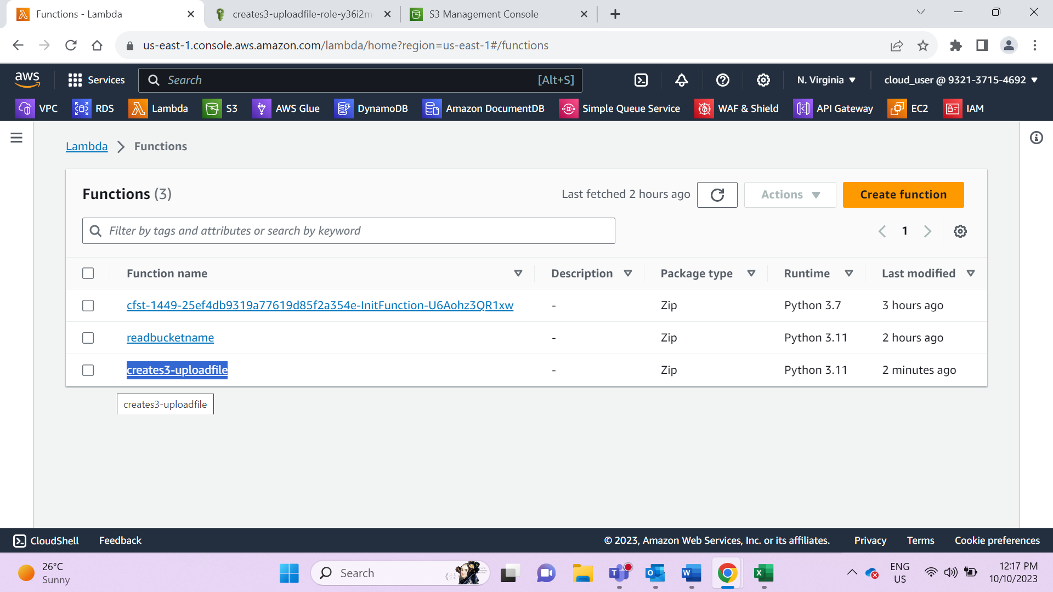

1. Add S3fullaccess Role to it

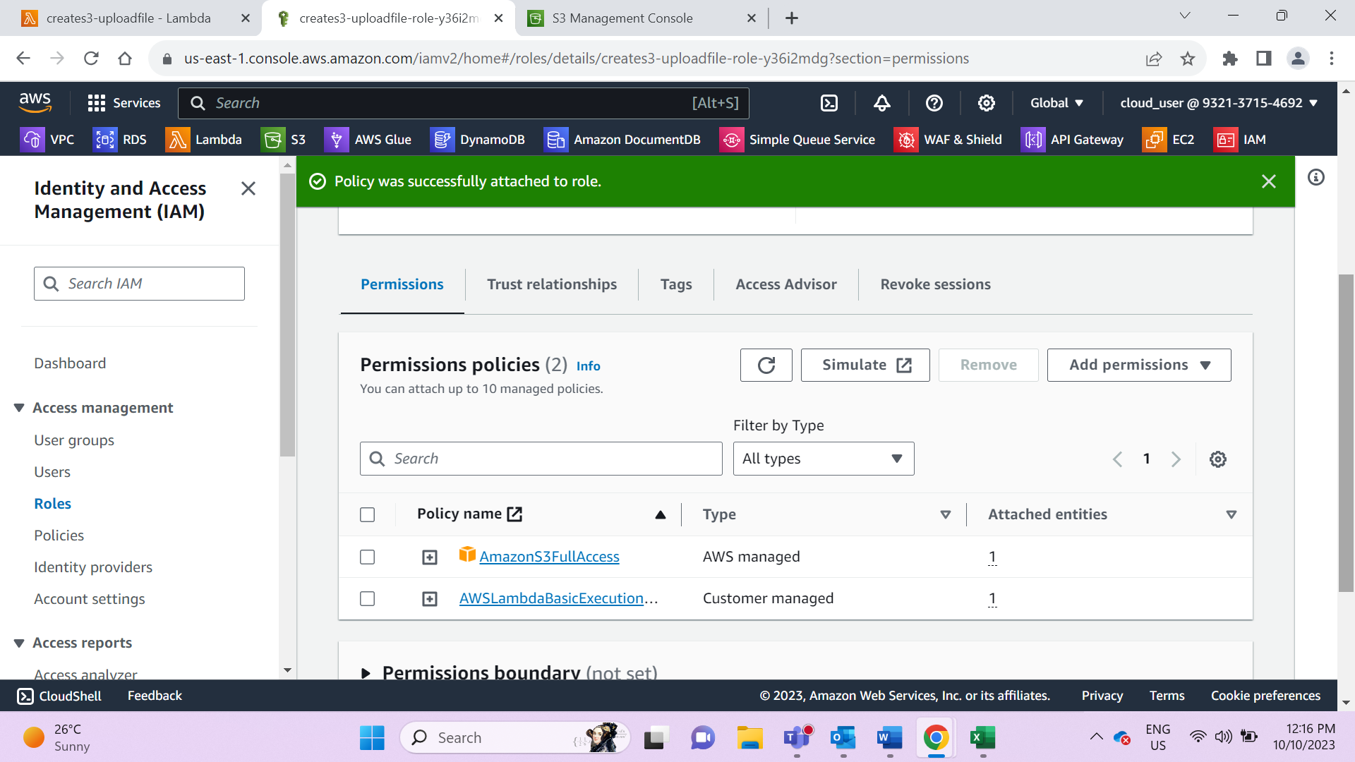

1. Lambda function executed successfully

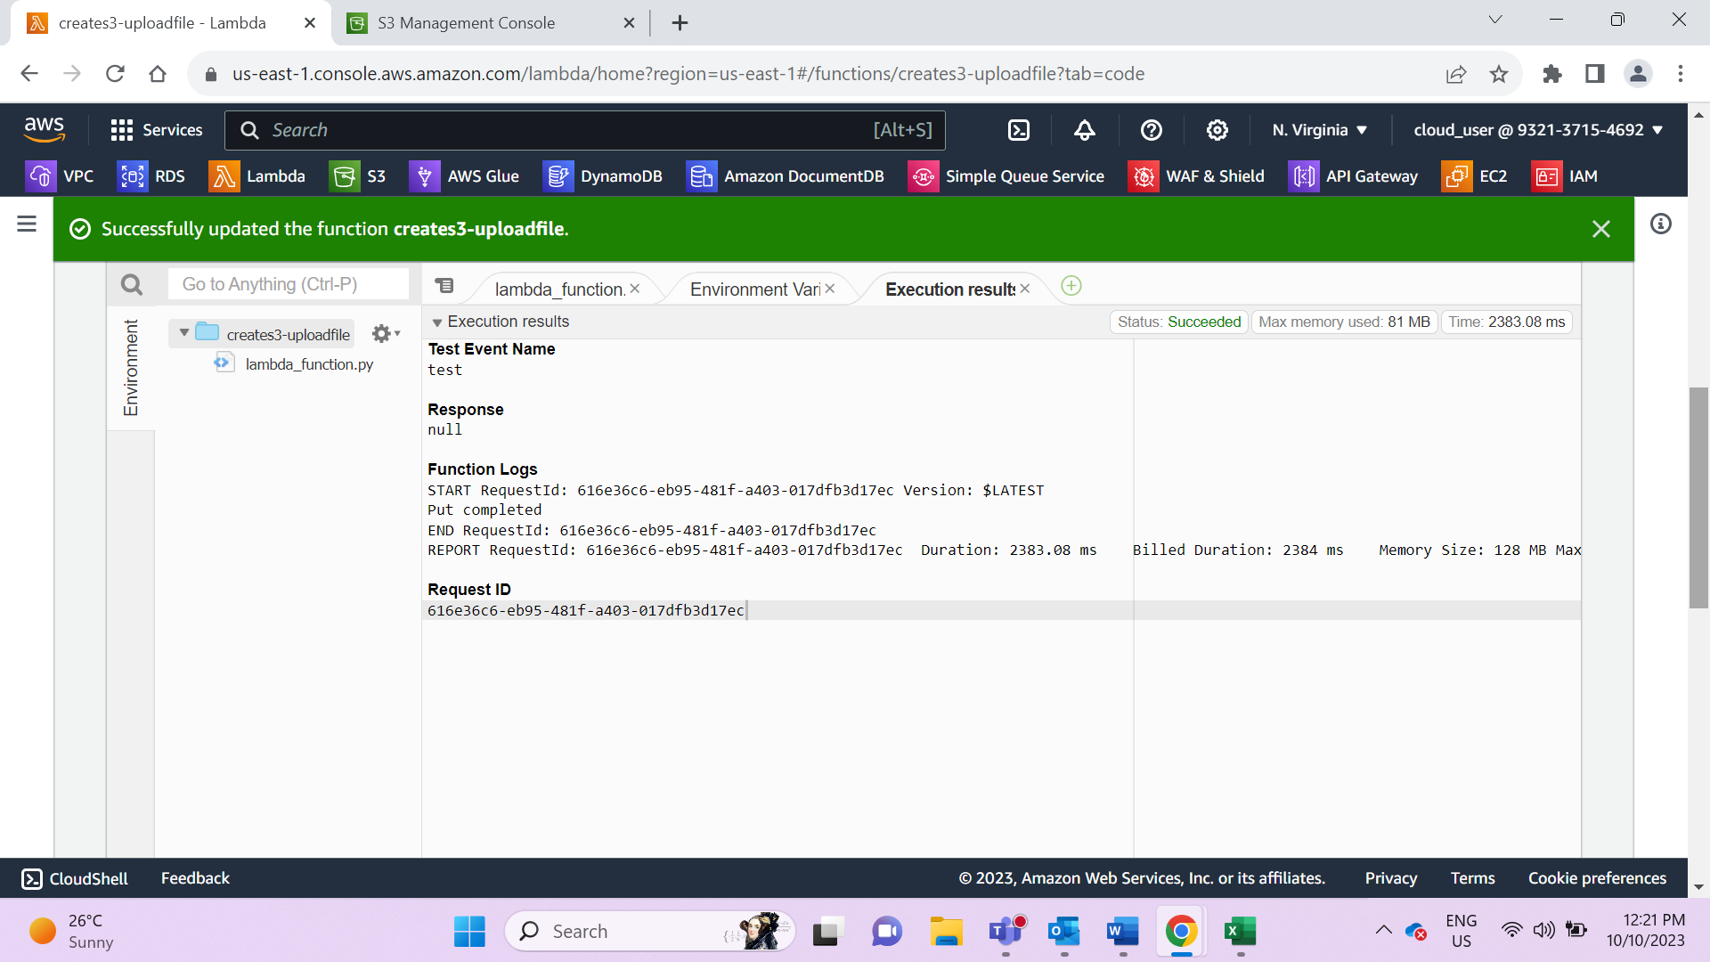

1. Check if bucket is created successfully

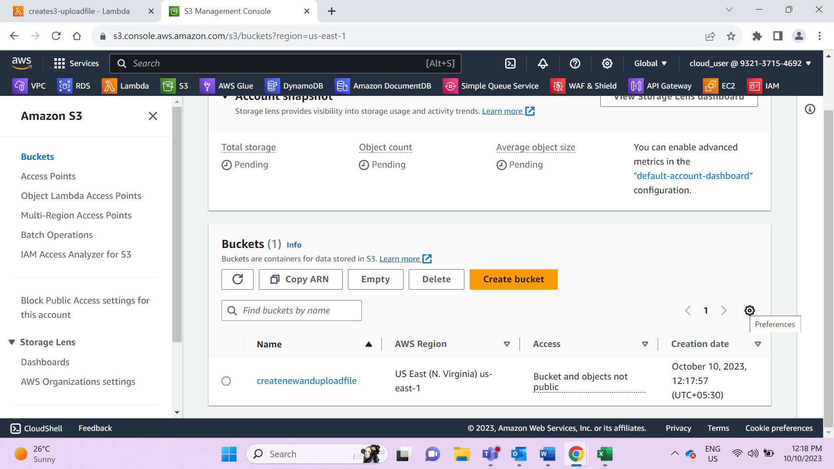

1. Validate if the file is loaded successfully

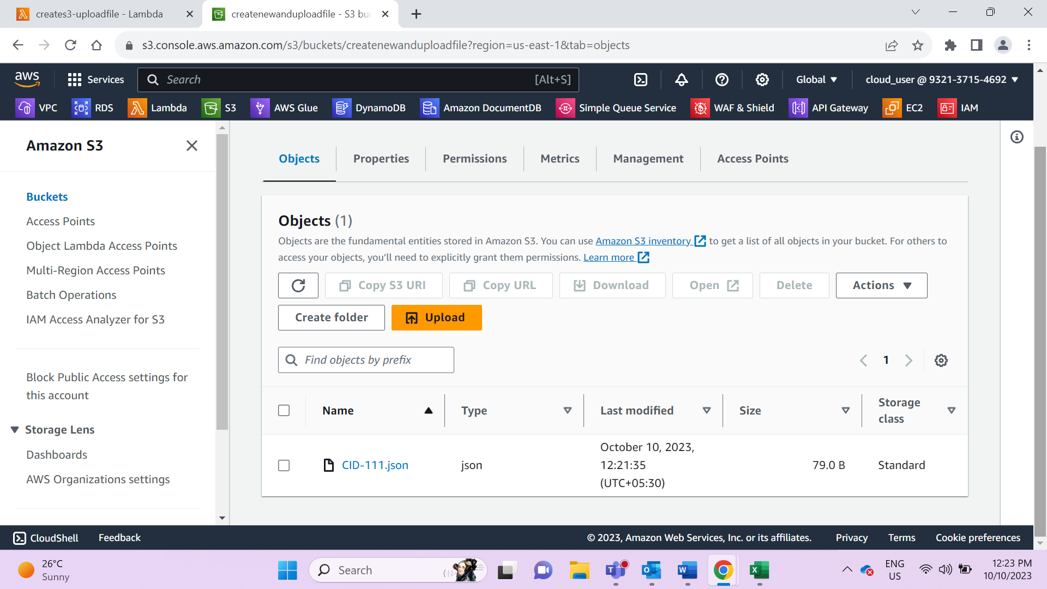

1. Add bucket policy to view the file

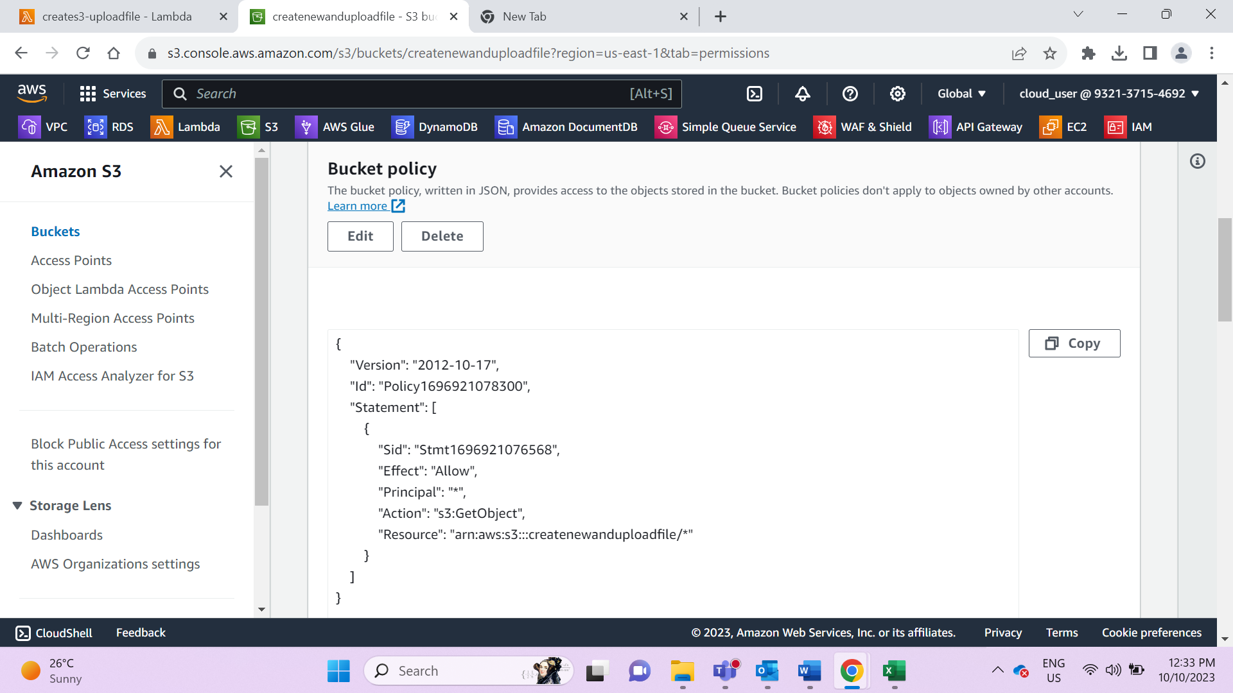

Code:

import json

import boto3

def lambda_handler(event, context):

s3=boto3.client('s3')

buckname="createnewanduploadfile"

try:

s3.create_bucket(Bucket=buckname)

except ClientError as e:

print("Choose difefrent bucket name")

transaction={}

transaction['transid']='123'

transaction['type']='PURCHASE'

transaction['amount']='30'

transaction['customerid']='CID-111'

fileName= 'CID-111' + '.json'

uploadByteStream= bytes(json.dumps(transaction).encode('UTF-8'))

s3.put_object(Bucket=buckname, Key= fileName, Body=uploadByteStream)

print('Put completed')